Unspoken Leadership
by Matt Renwick (https://mattrenwick.com)
Originally published at Choice Literacy (https://choiceliteracy.com)

This article explores the often-overlooked qualities of leadership, particularly in educational settings, emphasizing attributes like selflessness, empathy, and initiative, rather than traditional markers of success. Drawing from personal observations at a student recognition event, the author reflects on the importance of recognizing and cultivating these "unspoken leadership" traits, highlighting the value of diverse leadership styles and the potential impact they can have on a learning community.

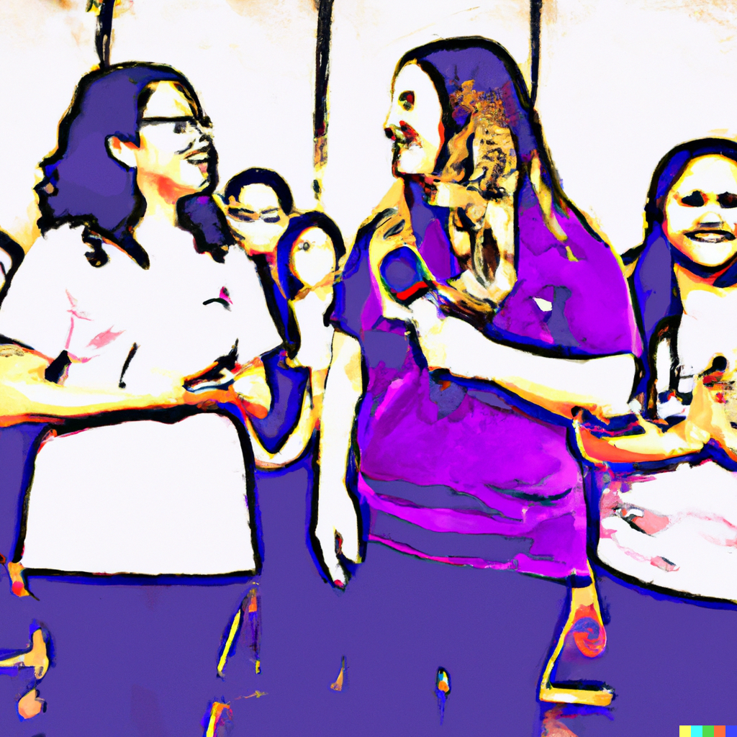
Image: Students being recognized in front of their peers (DALL-E)

I once attended a student recognition event at a local high school as a community leader. Students from various pathways were nominated by one of their teachers in their respective departments for going above and beyond what was expected.

What I discovered was that many of these students were not letterwinners on a varsity athletic team, or the lead in the school play. Nothing against those departments, but I appreciated that. As the teachers read their rationale for why each student was nominated, common attributes with regard to the qualities of each student were noticed: Selflessness. Empathy. Work Ethic. Initiative. Responsibility. These are the characteristics I would want to see in my own children.

What I also noticed was what was not mentioned. Traits such as intelligence, or being an outgoing personality were absent from the teachers’ descriptions of these deserving students. While these qualities in a person are to anyone’s advantage, they appeared not to be the main factor for recognition. Many of the students had what I would call “unspoken leadership”. I loosely define this as the elements of a person that are not readily recognized, but are just as essential to the growth and health of a learning community.

The Benefits of a Quiet Presence
These leadership traits were not covered in my graduate studies for the principalship. It doesn’t surprise me. Character is modeled better than it is taught. Susan Cain speaks to unspoken leadership in her excellent book Quiet: The Power of Introverts in a World That Can’t Stop Talking. In her chapter “The Myth of Charismatic Leadership”, she observed students at Harvard Business School, an institution teeming with extroverts (43). During class, the students were encouraged to speak out and make their presence known with their collaborative groups. What she discovered was, while the introverts had just as many great ideas as the the more vocal colleagues, they were often verbally dwarfed by their more exuberant peers.

The author goes on to point out that even though extroverted leaders are perceived by observers to be more capable and creative, many of our world’s most effective CEO’s, including Charles Schwab and Bill Gates, happen to be introverts. What they might lack in expressing themselves is offset by their abilities to listen to others objectively, not react immediately to stressful situations, and take the long view regarding the health of their respective organizations.

Room for All Types of Leadership
So do great leaders have to be introverts? Of course not. Leadership comes in many different packages. I highlight this information because I am also an introvert. I have never been comfortable in the limelight. I’d much rather have an intimate conversation with a few people who share my passion for learning and leadership, instead of speaking to a crowd about the same topic. Leadership comes in all shapes and sizes. At the same time, are there common threads that run through every effective example of leadership? Here are some initial thoughts:

A leader…
◦ Learns all the time,
◦ Purposefully seeks out new ideas and different viewpoints,
◦ Builds a network of diverse personalities and resources,
◦ Listens actively to others’ ideas,
◦ Acts decisively when necessary,
◦ Takes responsibility when things don’t go as planned,
◦ Keeps the organization moving forward, especially in the face of adversity,
◦ Recognizes individuals for going above and beyond what’s expected,
◦ Helps teachers hold themselves accountable when they are not meeting expectations, and
◦ Guides teachers to become leaders themselves.

I imagined those recognized high school students as I drafted this list of leadership attributes. I don’t find myself always meeting them.. Yet these characteristics are something to start at and to strive for as a literacy leader, every day. And that’s the promise of unspoken leadership: We can start again between dismissal and arrival with little fanfare and many possibilities. Who we were yesterday matters less than what we might accomplish today. Our presence of actions might make an impact on a student or teacher that lasts a lifetime.

